**Project Design Phase-II**

**Technology Stack (Architecture & Stack)**

|  |  |
| --- | --- |
| Team ID | PNT2022TMID39863 |
| Project Name | VirtualEye - LifeGuard for Swimming Pools to Detect Active Drowning |
| Maximum Marks | 4 Marks |

**Technical Architecture:**

The Deliverable shall include the architectural diagram as below and the information as per the table1 & table 2

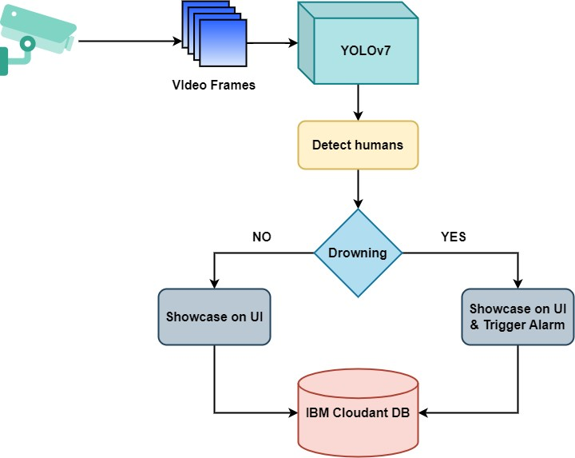

**Table-1 : Components & Technologies:**

|  |  |  |  |
| --- | --- | --- | --- |
| **S.No** | **Characteristics** | **Description** | **Technology** |
| 1. | Open-Source Frameworks | Anaconda Navigator, PyTorch, Flask, | Technology of Open-source framework |
| 2. | Security Implementations | Security / access controls | IAM Controls |
| 3. | Scalable Architecture | Whether demand increases gradually or abruptly, scalable web architecture can accommodate any load without compromising the application's integrity. | Microservies, Progressive Web Apps (PWA) |
| 4. | Availability | Availability of applications like load balancers, distributed servers etc. | IBM Cloud |

|  |  |  |  |
| --- | --- | --- | --- |
| **S.No** | **Component** | **Description** | **Technology** |
| 1. | User Interface | How user interact with the application | HTML, JavaScript, CSS |
| 2. | Application Logic-1 | Extracting frames from live video feed | Python |
| 3. | Application Logic-2 | Person Detection | Python |
| 4. | Application Logic-3 | Detect drowning | Python |
| 5. | Database | Data Type, Configurations etc. | MySQL, NoSQL, etc. |
| 6. | Cloud Database | Database Service on Cloud | IBM Cloudant DB |
| 7. | File Storage | File storage requirements | IBM Block Storage or Other Storage Service or Local Filesystem |
| 8. | Machine Learning Model | Detect humans | Object Detection Model (YOLOv7) |
| 9. | Infrastructure (Server / Cloud) | Application Deployment on Cloud | Cloud Foundry, Docker. |

**Table-2: Application Characteristics:**

|  |  |  |  |
| --- | --- | --- | --- |
| **S.No** | **Characteristics** | **Description** | **Technology** |
| 5. | Performance | Designing the system software that can monitor a wide range of swimming pool at a time without any delay and to provide accurate predictions | IBM instance |